OVUS PRODUCT & PRICE LIST 2020
Multi-Panel UA Test Cups - FREE SHIPPING
DRUGS TESTED
AMP, BAR, BUP, BZO, COC, MAMP (MET), MDMA, MTD, OPI300 (MOP), OXY, THC, TML, FYL & EtG
DRUGS TESTED
AMP, BAR, BUP, BZO, COC, MAMP, MDMA, MTD, OPI300, OXY, THC, PCP or TCA
12 PANEL
w/PCP or TCA
DRUGS TESTED
ALC, AMP, BAR, BUP, BZO, COC, HCG, MAMP (MET), MDMA, MTD, OPI300 (MOP), OXY, THC, & FYL
DRUGS TESTED
AMP, BAR, BUP, BZO, COC, MAMP (MET), MDMA, MTD, OPI300 (MOP), OXY, THC, PCP & FYL
DRUGS TESTED
AMP, BAR, BUP, BZO, COC, MAMP (MET), MDMA, MTD, OPI300 (MOP), OXY, THC 3 adulterations
(Specific Gravity, pH, & Creatinine)
DRUGS TESTED
AMP, BUP, BZO, COC, MAMP,
OPI300, OXY, THC
DRUGS TESTED
AMP, BUP, BZO, COC, MAMP, MDMA, MTD, OPI300, OXY, THC
DRUGS TESTED
AMP, BUP, BZO, COC, OPI300, OXY
14 PANEL
w/ETG. FYL
14 PANEL
w/ ALC, FYL, HCG
13 PANEL
12 PANEL
w/ Adulterants
10 PANEL
8 PANEL
6 PANEL

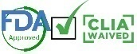

- 1 cup $4.99ea
5 cups $4.89ea
- 10 cups $4.79ea
- 25 cups $3.99ea
- 50 cups $3.99ea
- 75 cups $3.99ea
- 100 cups $3.99ea
- 300 cups $3.69ea
- 500 cups $3.59ea
- 700 cups $3.49ea
- 1000 cups $3.39ea
- 1500 cups $3.29ea
- 2000 cups $3.19ea
- 1 cup $2.99ea
5 cups $2.89ea
- 10 cups $2.79ea
- 25 cups $2.39ea
- 50 cups $2.39ea
- 75 cups $2.39ea
- 100 cups $2.39ea
- 300 cups $2.29ea
- 500 cups $2.19ea
- 700 cups $2.14ea
- 1000 cups $2.09ea
- 1500 cups $2.04ea
- 2000 cups $1.99ea
- 1 cup $3.99ea
5 cups $3.94ea
- 10 cups $3.89ea
- 25 cups $3.49ea
- 50 cups $3.49ea
- 75 cups $3.49ea
- 100 cups $3.49ea
- 300 cups $3.39ea
- 500 cups $3.29ea
- 700 cups $3.24ea
- 1000 cups $3.19ea
- 1500 cups $3.14ea
- 2000 cups $3.09ea
- 1 cup $3.99ea
5 cups $3.99ea
- 10 cups $3.79ea
- 25 cups $3.29ea
- 50 cups $3.29ea
- 75 cups $3.29ea
- 100 cups $3.29ea
- 300 cups $3.24ea
- 500 cups $3.19ea
- 700 cups $3.14ea
- 1000 cups $3.09ea
- 1500 cups $3.04ea
- 2000 cups $2.99ea
- 1 cup $3.99ea
5 cups $3.89ea
- 10 cups $3.49ea
- 25 cups $3.29ea
- 50 cups $3.29ea
- 75 cups $3.29ea
- 100 cups $3.29ea
- 300 cups $3.24ea
- 500 cups $3.19ea
- 700 cups $3.14ea
- 1000 cups $3.09ea
- 1500 cups $2.99ea
- 2000 cups $2.89ea
- 1 cup $2.99ea
5 cups $2.94ea
- 10 cups $2.89ea
- 25 cups $2.79ea
- 50 cups $2.79ea
- 75 cups $2.79ea
- 100 cups $2.79ea
- 300 cups $2.69ea
- 500 cups $2.59ea
- 700 cups $2.54ea
- 1000 cups $2.49ea
- 1500 cups $2.39ea
- 2000 cups $2.29ea
- 1 cup $2.99ea
5 cups $2.94ea
- 10 cups $2.89ea
- 25 cups $2.69ea
- 50 cups $2.69ea
- 75 cups $2.69ea
- 100 cups $2.69ea
- 300 cups $2.49ea
- 500 cups $2.39ea
- 700 cups $2.34ea
- 1000 cups $2.19ea
- 1500 cups $2.14ea
- 2000 cups $2.09ea
- 1 cup $2.99ea
5 cups $2.94ea
- 10 cups $2.89ea
- 25 cups $2.59ea
- 50 cups $2.59ea
- 75 cups $2.59ea
- 100 cups $2.59ea
- 300 cups $2.49ea
- 500 cups $2.39ea
- 700 cups $2.34ea
- 1000 cups $2.19ea
- 1500 cups $2.14ea
- 2000 cups $2.04ea

Kratom
Marijuana
Methamphetamine
Methylphenidate
Opiates
Oxycodone
Pregnancy
Propoxyphene
Synthetic Cannabinoids
Tramadol
Tricyclic Antidepressants
Propoxyphene
KRA
THC
MET
MPD
OPI
OXY
HcG
PPX
K2
TRA
TCA
PPX

LSD
GHB
AMP
BZO
BUP
CLON
COC
COT
ETG
FYL
KET
MAM

Lysergic Acid Diethylamide
Gamma-hydroxybutyric
Amphetamine
Benzodiazepine
Buprenorphine
Clonazepam
Cocaine
Cotinine ˙
Ethyl Glucuronide
Fentanyl
Ketamine
Heroin

DRUG TEST ABBREVIATION KEYS

ORAL SWABS
UA TEST STRIPS

25/pk-$19.75
25/pk-$14.75
1/pk- $1.99
25/pk-$49.75
25/pk-$22.25
25/pk-$14.75
25/pk-$14.75
25/pk-$34.75
25/pk-$19.75
25/pk-$24.75
25/pk-$14.75
25/pk-$19.75
25/PK-$19.75
COT
AMP
KRA
GHB
FYL
COC
MET
LSD
PPX
CLON
TRA
PCP
KET

hCG
BZO
OXY
OPI
SUB
TCA
THC
ETG
K2
MPD
BAR
LH
MAM
25/pk-$14.75
25/pk-$14.75
25/pk-$14.75
25/pk-$14.75
25/pk-$14.75
25/pk-$14.75
25/pk-$19.75
25/pk-$17.25
25/pk-$19.75
25/pk-$37.25
25/pk-$14.75
25/pk-$14.75
25/pk-$19.75

10 PANEL ORAL SWABS TEST FOR:
THC, AMP, COC, OPI/MOR, BAR, BZO, BUP, OXY, PCP, MET

1 swab ($3.99ea)
5 swabs ($3.95ea)
10 swabs ($3.79ea)
25 swabs ($3.49ea)
50 swabs ($3.49ea)
75 swabs ($3.49ea)
100 swabs ($3.49ea)
300 swabs ($3.39ea)
500 swabs ($3.29ea)
700 swabs ($3.19ea)
1000 swabs ($3.09ea)

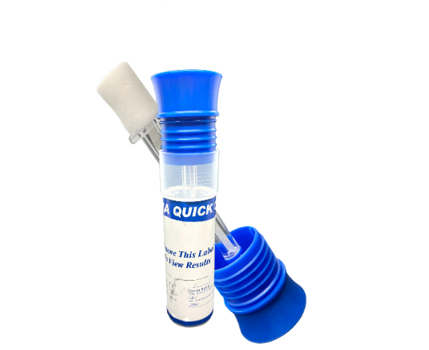

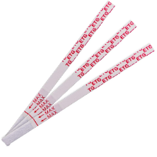

DIP CARDS

THC ONLY
DIP CARD
C
10 PANEL
DIP CARD
12 PANEL
DIP CARD
13 PANEL
DIP CARD

TESTS FOR: THC
$1.69ea
DRUGS TESTED
AMP, BUP, BZO, COC, MDMA, THC, MTD, mAMP (or MET), OXY, OPI
DRUGS TESTED
AMP, BAR, BUP, BZO, COC, MDMA, THC, MTD, mAMP
OXY, OPI, TCA
DRUGS TESTED
AMP, BAR, BUP, BZO, COC, FYL, MDMA, THC, MTD, mAMP, OXY, OPI, TCA

1 dip card ($2.99)
5 dip cards ($2.89)
10 dip cards ($2.79)
100 dip cards ($2.39)
300 dip cards ($2.29)
500 dip cards ($2.19)
700 dip cards ($2.09)
1000 dip cards ($1.99)
1500 dip cards ($1.94)
2000 dip cards ($1.89)
1 dip card ($2.59)
5 dip cards ($2.49)
10 dip cards ($2.39)
100 dip cards ($1.99)
300 dip cards ($1.89)
500 dip cards ($1.79)
700 dip cards ($1.69)
1000 dip cards ($1.64)
1500 dip cards ($1.59)
2000 dip cards ($1.54)

1 dip card ($1.99)
5 dip cards ($1.89)
10 dip cards ($1.79)
100 dip cards ($1.69)
300 dip cards ($1.59)
500 dip cards ($1.49)
700 dip cards ($1.44)
1000 dip cards ($1.39)
1500 dip cards ($1.34)
2000 dip cards ($1.29)

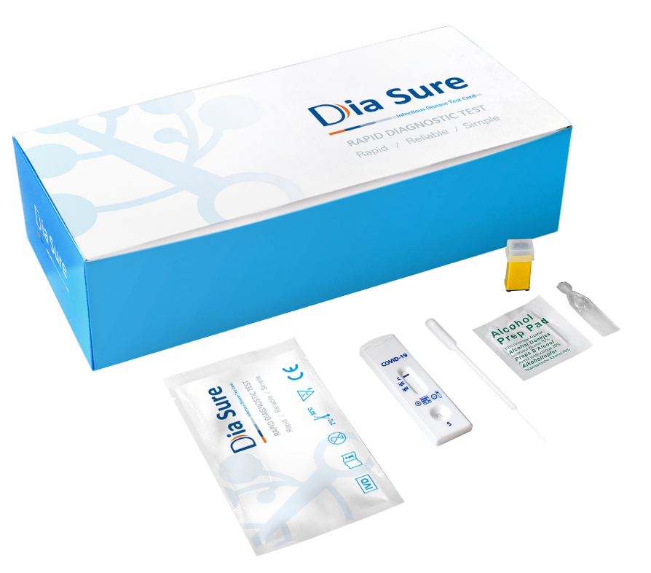

Coronavirus Rapid Test (Covid-19 IgG/IgM)

Professional use only – EUA Authorized

FREE SHIPPING ON ALL ORDERS

- 1 box - $279.80 per box ($13.99ea)
- 3 boxes - $239.80 per box ($11.99ea)
- 5 boxes - $219.80 per box ($10.99ea)
- 10 boxes - $199.80 per box ( $9.99ea)
- 20 boxes - $179.80 per box ( $8.99ea)
- 40 boxes - $169.80 per box ( $8.49ea)

AUTHORIZATION: Use of this test with all authorized specimen types is limited to
laboratories certified under the Clinical Laboratory Improvement
Amendments of 1988 (CLIA), 42 U.S.C. 263a, that meet
requirements to perform moderate or high complexity tests.
This test is also authorized for use with fingerstick whole blood
specimens only at the Point of Care (POC), i.e., in patient care
settings operating under a CLIA Certificate of Waiver, Certificate
of Compliance, or Certificate of Accreditation.

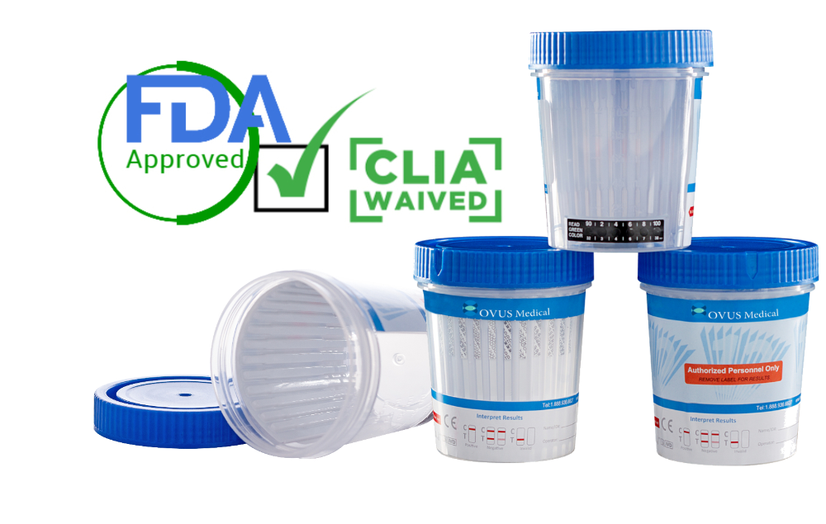

WWW.OVUSMEDICAL.COM

FOR MORE INFO: JS@OVUSMEDICAL.COM

JS@OVUSMEDICAL.COM
Ph: 1.800.921.8241 Fax: 1.888.882.4817

